# [**Law And Order: SVU is Subtly Preparing Stabler To Finally Settle Down**](https://startefacts.com/news/game-of-thrones-finale-we-deserved-george-martin-s-original-outline_a123)

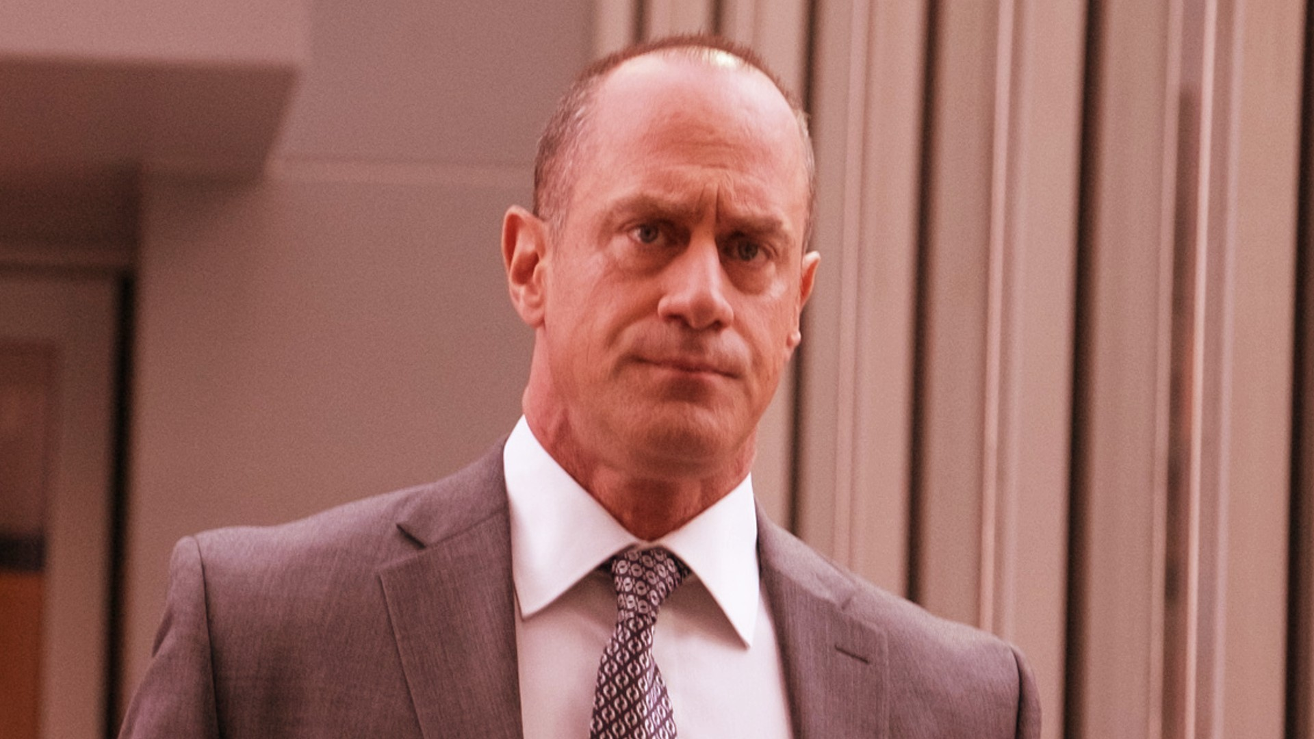Image credit: globallookpress

Elliot Stabler has always been an emotional character throughout his time on SVU, relating heavily to the cases he works on. However, after his wife's death, he has proven to be a bit of a rogue over the first few seasons of L&O: Organized Crime.

Clearly showing signs of PTSD, Stabler has become a bit of a loner, and with his daughter Eli leaving for college he appears more alone than ever. However, recent episodes of the spin-off series suggest that Stabler may be starting to move past his trauma and settle down shortly after all.

**[Warning: season spoilers ahead]**

During one of the latest episodes of season three, All That Glitters, the show sees Stabler reconnect with an old female colleague from Italy and potential old flame Agent Tia Leonetti.

The episode initially glimpses potential chemistry between the pair, as the finale sees Leonetti at his door teasing a possible fling between the two. Ending expectantly on a cliffhanger. However, the following episode quickly sets the record straight, revealing they never slept with each other and remain only close friends. But this does not mean all is lost for Stabler's love life.

[Is It January Yet? Fans Hoping for Improvement in Blue Bloods Season 13](https://startefacts.com/news/is-it-january-yet-fans-hoping-for-improvement-in-blue-bloods-season-13_a118)

During a conversation between the two friends, Leonetti divulges a confession made by Stabler the night before of his affection for another woman. Unfortunately, the identity of the woman he truly has feelings for is left nameless.

It is not too difficult for fans to know who Stabler is likely referring to anyway. Feelings between him and his old SVU partner, Olivia Benson have always been alluded to. And this has only been increasingly implied over the last few seasons of the show. For instance, back in season one of OC, Stabler blurts out "I love you" to Benson during a drunken intervention. He slightly misdirects it at the time, correcting that he loves all of his family. Yet in a voicemail to Benson in season two, he again addresses the admission, but the audience is cut-off before more about his feelings is said.

Organized Crime isn't the only series in the franchise to have been teasing a pairing between the two. In SVU, Benson's therapist suggested she should potentially explore a relationship with him. As did fellow detective Amanda Rollins, who insinuated maybe the two should get a hotel room together to clear the tension. Hints at a growing connection between the detectives have clearly existed for some time, but up till this point have been few and far between.

[Criminal Minds Revival: Where Nothing Makes Sense, but We'll Keep Watching Anyway](https://startefacts.com/news/criminal-minds-revival-where-nothing-makes-sense-but-we-ll-keep-watching-anyway_a115)

When Stabler and Benson will eventually get together is difficult to say. There is still the Christmas episode of this season's OC left to air. Although it's possible we may see the consummation of each other's affections then, nothing can be said for certain. Law and Order have certainly been leading up to the stoic detective settling down for some time. And after all these years, fans of Benson and Stabler might finally get what they've been waiting for very soon.